Seascale’s Journey

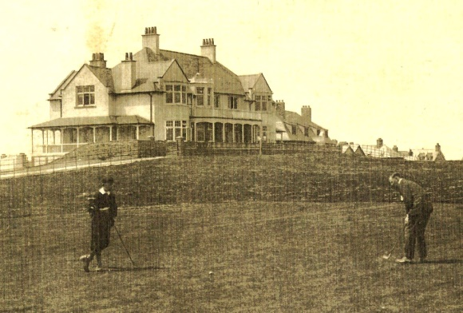

If early plans for Seascale had come to fruition with an extensive promenade, villas, hotels and guest houses most of the way to Sellafield, then Seascale Golf Club might have developed elsewhere – perhaps even at Sellafield or Drigg. Thankfully, on the crest of the spread of the ‘Scottish game’ into late Victorian Britain, the members were able to establish their course as one of the earliest in Cumbria on what is now a superb piece of traditional rolling links. Essentially the initiative of local residents in 1893, its success in attracting visitor revenue quickly resulted in the provision of a substantial three-story clubhouse on its present location. The first nine holes were laid out by Willie Campbell of Bridge of Wier, and in 1899 the course was extended to 18 holes by George Lowe of Lytham St Annes Golf Club.
In the years up to the First World War the Club went from strength to strength attracting many exhibition matches including that between Sandy Herd of Huddersfield and the legendary Harry Vardon, the Open Champion for 1902.

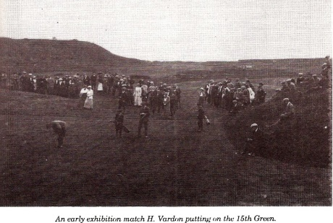
The Club was lucky to have as its Professional – Greenkeeper – Club-maker - Mr C C Anderson who served the Club dutifully for 42 years starting at a wage of £1 per week. The first Steward of the Club might be considered to be a Mrs Skinner who was engaged to provide teas from the ladies room of the early hut-style clubhouse, but it wasn’t long before better facilities were required. The new clubhouse was completed and opened by Lord Muncaster in January 1907 with a luncheon for 74 members and friends. Members joining fee was 3 guineas and the annual subscription £1 11/6 in 1908, and typical bar prices for members and visitors were:
Whisky per glass 4d (Today worth £4 – but how big was a glass?)
Lager per bottle 3d
Stout per bottle 3d
Stone Ginger per bottle 2d
Shwepps(spirit)per bottle 2d
J & B Soda 3d
J & B Dry Ginger 3d
Cider 3d

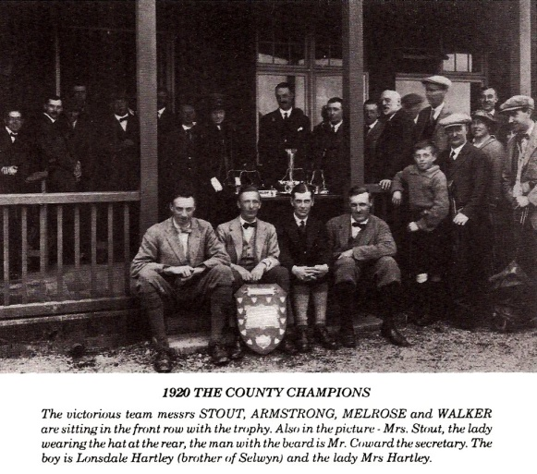

Post-First World War was a period of establishment of the playing reputation of the Club, winning the County Championships at home in 1920 and again in 1931 at Workington with players like Stout, Armstrong, Melrose and Walker. Bill Stout was perhaps the finest player to come out of the Club winning the English Championships in 1930 and going on to gain Walker Cup honours in 1930 and 1932. However, the inter-war years were testing to say the least on Club finances and with the Second World War things got even worse with staff shortages, drastic cuts in membership and visitors meaning that maintenance suffered to such an extent that the course was reduced to 14 holes. Matters indoors were just as bad as the dining room closed and whisky sales were reduced to a bottle and a half per week through rationing – and there was a ban on ‘treating’ at the bar.
The austerity period up to the late 1950’s saw the Club trying to drag itself back into a solvent position and by 1957 a motion to increase membership fees by 40%, making men’s subscriptions £10 10/- and ladies’ £7 7/- seemed to push things back on track. A major step forward was taken in the early 1960’s as the Club went on to purchase the land that had up until that point been rented under lease. A much needed extension to the Clubhouse was required to accommodate the needs of the growing membership and this was completed by mid-1967 with ‘basket suppers’ supplied on the opening night. The quality of golf was improving steadily and names like French, Gulliksen, Richardson, Stavert, Hartley, Long, Walls, Clucas and Rushton became regulars on the County circuit. By 1976 a new team had taken over with Dave and Sandra Tomkinson as steward and stewardess, Tony Bacon as professional and Ron Brown as greenkeeper.
The periods of high inflation in the 70’s and 80’s nevertheless meant the Club had to run fast to try to keep its head above water. But the efforts of the likes of Jim Woods, Don Blythe, Harry Graham and others meant that the Club with a supportive membership could enter its second century acquiring more land to be used as a driving range and provide the necessary room for expansion. The Club could also contemplate and complete in the mid-90s a much needed refurbishment of the Clubhouse providing improved locker rooms, bar, lounge, dining room and catering facilities. Talent still oozed out with Glen Shuttleworth and Simon Young foremost in the new but now recumbent talent – might we expect some of our low handicappers to emulate their achievements sometime soon? With the new millennium the popularity of the game saw a new course at Whitehaven, a major attraction on the doorstep for many Seascale members, leading to a drift of membership – and as with every club nationally the economic climate post-2007 posed severe financial problems. However, the Seascale Club has ridden these stormy seas and finds itself in much calmer waters, with its superior course, excellent facilities and buoyant visitor numbers.
Up to the 1980’s the Club still reflected the good old colonial-style appearance with plenty of rules to keep members, visitors – and ladies in check. The Club was, like most golf clubs, rather slow to give ladies their rights, keeping them out of the gentlemen’s bar, accessed only by a hole in the wall. A bit unfair on what was often 40% of its membership. As it reached its centenary in 1993 there were moves to a more accommodating environment, made more immediate by the grants from the Sports Council etc towards the refurbishment of the Club, which required the encouragement of equal opportunities for all. More recently in 2011, the Seascale Club cast off what was to some the stuffy image and threw its doors open to the wider public. Not a lot of people know that – one might say.
The Club is now on a journey to make its facilities available to the wider community. Its situation, with that magical vista over the Wasdale Valley up to Scafell, surely gives it the most desirable view in Britain, perfect for any organisation wishing to book its conference facilities, or for anyone wishing to book that special christening, birthday, retirement or any other special event. Kirsty Johnson the House Manger and Richard Minniken Head Chef are cooking up quite a recipe to entice people into the Clubhouse.

Welcome to ‘The Clubhouse’

In keeping with the aim of attracting a wider customer base, our facilities are now being marketed as ‘The Clubhouse.’ – as announced in the most recent edition of the Seascale Guide, itself undergoing a change of name to ‘Tethera’ – Good luck to both.

