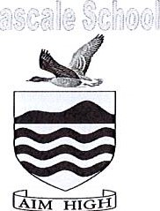
Seascale Primary School
Croft Head Road, Seascale, Cumbria, CA20 ILZ
TEL: 01946 728403 Website: www.seascaleschool.co.uk
E-MAIL: admin@seascale.cumbria.sch.uk
HEADTEACHER: Mrs A Spencer

SEASCALE PRIMARY SCHOOL – CROSSING PATROL VACANCY

The school currently has one person who works the following shifts:
Monday afternoon — 3.00 — 3.30 pm
Tuesday morning — 08.30 — 9.10 am
Wednesday morning — 08.30 — 9.10 am
Thursday afternoon — 3.00 — 3.30 pm
Friday afternoon — 3.00 — 3.30 pm
We seek another to work the opposite shifts. If you are interested, please contact the school for further information.

